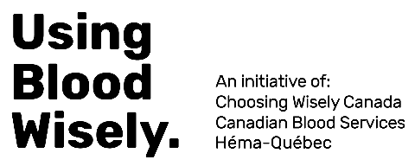
Using Blood Wisely:
Information for Patients

The information below can be incorporated into a transfusion pamphlet or pre-operative assessment clinic package for patients undergoing high blood loss surgery such as cardiac surgery, orthopedic surgery, or cancer surgery.

For Patients Who May Require Transfusion
Blood is a vital and limited health care resource. Using blood wisely ensures that it is available for those who need it most. Because of the risks of transfusion, our hospital participates in the Using Blood Wisely initiative, organized by Choosing Wisely Canada and Canadian Blood Services.
The initiative uses scientific evidence to guide when and how red blood cell transfusions should be used. Specifically, it means that we:
- Transfuse red blood cells only after considering safer, non-transfusion alternatives (e.g. iron);
- Transfuse red blood cells based on your overall clinical symptoms and rather than just your hemoglobin level; and
- Transfuse one red blood cell unit at a time in non-bleeding patients.

If you have questions, ask your health care provider for more information.

